Analysis Report

- Introduction
This project aims to develop an AI-driven Cybersecurity Framework designed to enhance Intelligent Threat Detection and Analysis. In the modern digital landscape, security teams face an overwhelming volume of cyber threats, ranging from malware and phishing to sophisticated network intrusions. This project provides a unified, web-based platform that automates the detection, analysis, and reporting of these threats. By integrating Artificial Intelligence into core security operations, PAPILLON intends to improve the situational awareness of Security Operations Centers (SOCs) and reduce the cognitive load on analysts.

- Current system (if any)

- Proposed system

  - Overview
The proposed system is a monolithic web application built using the Django framework. It serves as a centralized hub for SOC analysts. The architecture is designed to be modular, utilizing a message-queue and worker pool system to handle heavy asynchronous tasks like ML inference and parsing, ensuring the main dashboard remains responsive. The system integrates external APIs (NVD, ExploitDB) and uses AI models to automatically classify threats.

  - Functional Requirements
- Blacklist IP Management: Users can manage (Create, Read, Update, Delete) blacklisted IP addresses. The system validates IPv4/IPv6 formats and logs all changes.
- Automated CVE Fetching: The system automatically pulls vulnerability data (CVEs) from NVD/ExploitDB at least every 12 hours, normalizes the data, and stores it.
- Attack Surface Analysis: The platform scans verified domains for subdomains, open ports, and SSL validity, executing these scans in an isolated environment.
- IDS Integration: The system accepts webhook alerts from Intrusion Detection Systems (IDS), normalizes the logs, and displays them on the dashboard in real-time.
- Attack Simulation: Authorized users can trigger controlled attack scenarios in a sandboxed environment to test defenses.
- Phishing Detection: The system connects to user mailboxes via OAuth, parses emails, and uses an ML model to score them for phishing probability.
- Malware Analysis: Users can upload suspicious files, which are analyzed in a sandbox to extract PE features and classified by an AI model.
- Cryptography Module: A built-in utility provides AES-256 and RSA encryption/decryption functions, with secure key management.
- Reporting: Users can generate customizable PDF reports summarizing security findings, logs, and scan results.
- RBAC & Security: The system enforces Role-Based Access Control (Admin, Analyst, ReadOnly) and requires Two-Factor Authentication (2FA) for administrative roles.

  - Nonfunctional Requirements
- Performance:
  - IDS alerts must be visualized on the dashboard within 2 seconds.
  - ML inference for threats must complete within 5 seconds.
  - Phishing email processing should take ~30 seconds.
- Reliability: The system targets a 99% availability rate.
- Accuracy: The Phishing Model requires a Precision >= 0.90, and the Malware Detection Model requires an F1-Score >= 0.85.
- Security: Passwords must be hashed (Argon2/Bcrypt), and 2FA is mandatory for privileged accounts.

  - Pseudo requirements
- Architecture: The system must be a Monolithic application to simplify deployment for the academic scope.
- Tech Stack: The backend must be developed in Python Django and use MySQL as the database.
- Environment: Testing and deployment are limited to controlled laboratory environments or verified domains; no live enterprise deployment is permitted.
- Timeline: Development is strictly bound by the academic semester schedule

  - System models
    - Scenarios
One primary scenario is the End-to-End IDS Alert Flow:
- An external IDS detects suspicious traffic and sends a webhook payload to the PAPILLON API Collector.
- The API Collector validates the request schema and enqueues the job to RabbitMQ.
- A Normalizer Worker picks up the job, standardizes the log format (timestamp, source IP), and persists it to the database.
- An Inference Worker subsequently runs the anomaly detection ML model on the normalized data.
- Finally, the result is pushed via WebSocket to the Analyst's Dashboard, appearing as a new alert card within 2 seconds.

    - Use case model
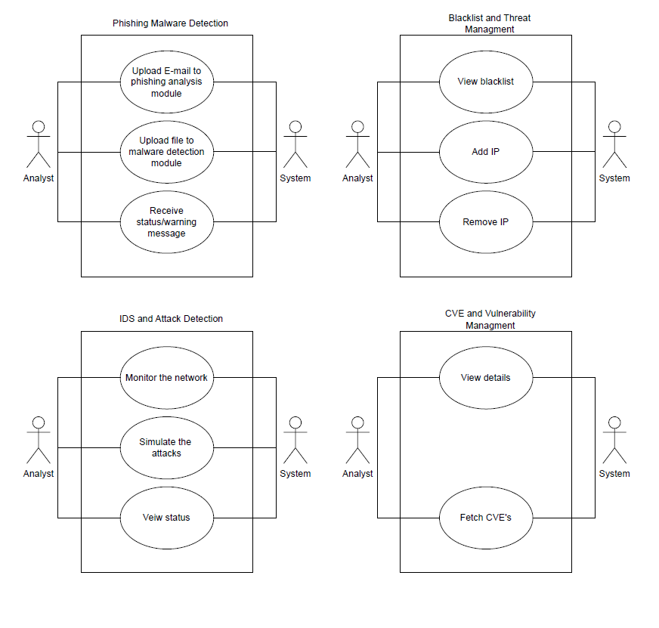

    - Object and class model
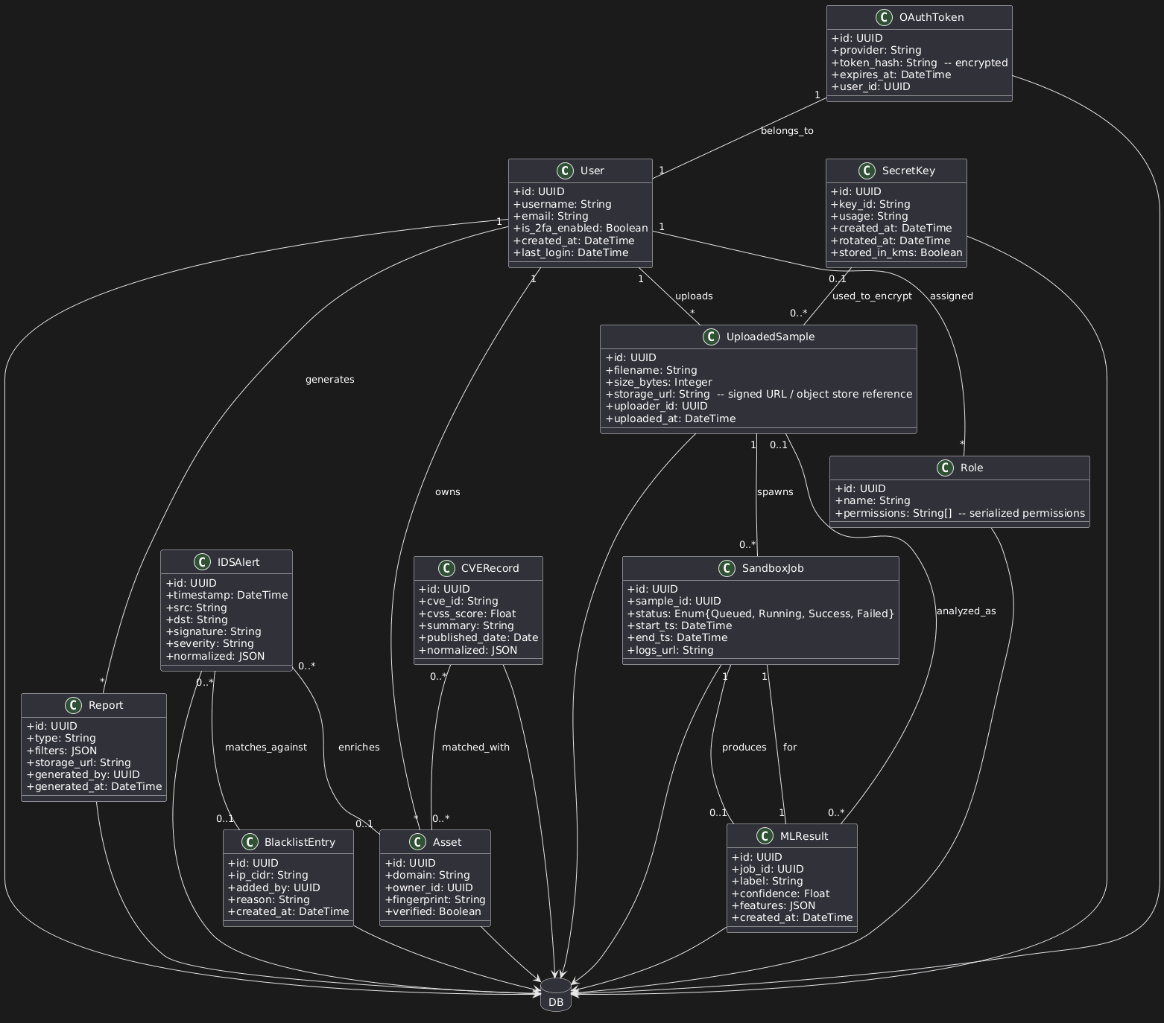

    - Dynamic models
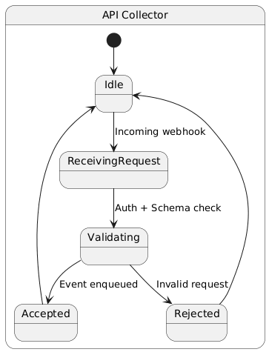
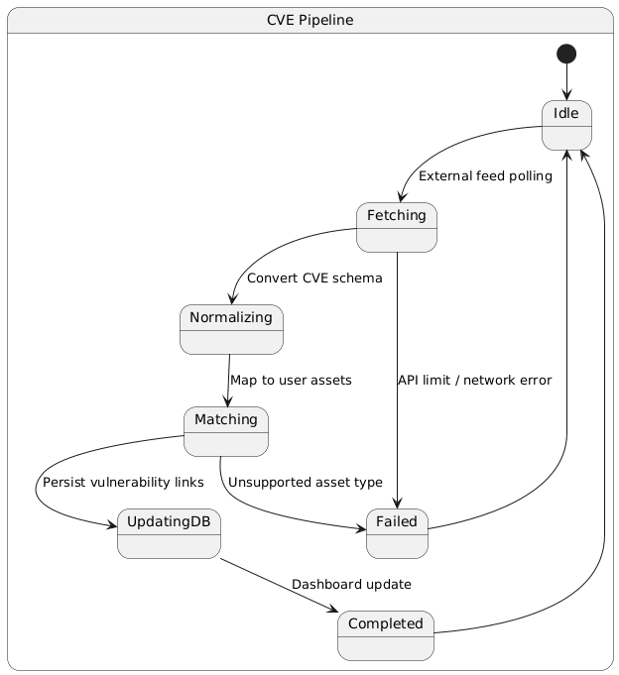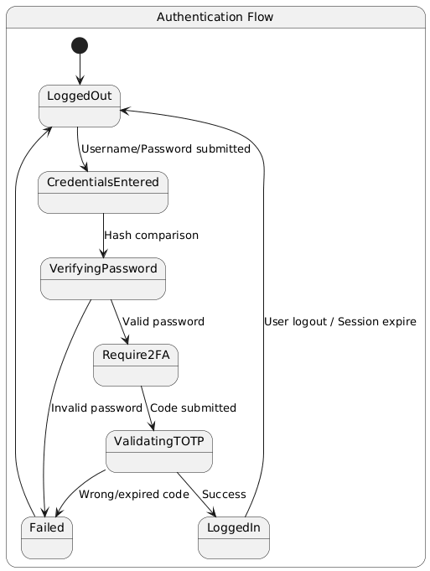

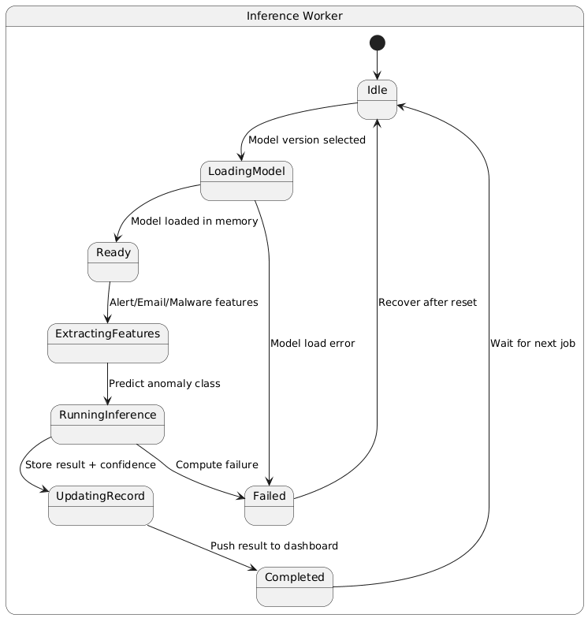
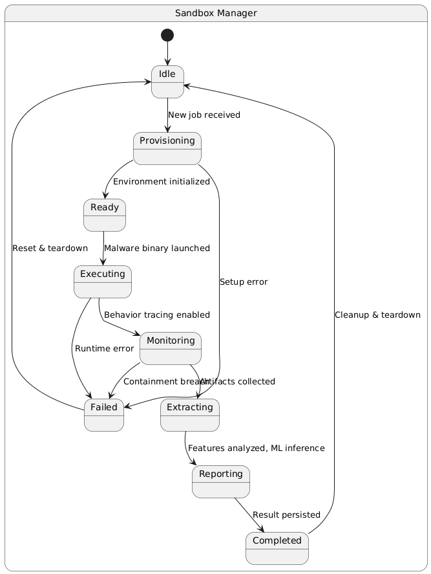
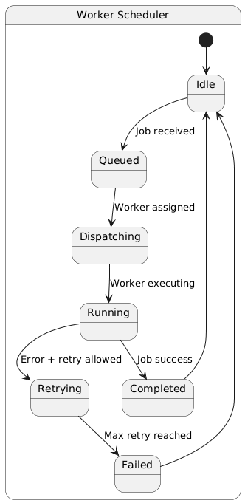
    - User interface - navigational paths and screen mock-ups
- Dashboard: Real-time graphs of alerts and network traffic.
- Threat Intelligence: Views for Blacklisted IPs and CVE Monitor.
- Analysis Tools: Tabs for "Attack Surface Scan", "Malware Analysis” and "Phishing Detection".
- Reports: A section to configure filters and download PDF reports.
- Settings: Profile management and 2FA configuration.

- Glossary
- SOC – Security Operations Center
- CVE – Common Vulnerabilities and Exposures
- IDS - Intrusion Detection System
- TOTP – Time-based One-time Password
- RBAC – Role-based Access Control

- References
- Project Proposal Document v3.0.
- Software Requirements Specification (SRS) v2.0.
- Software Design Description (SDD) v1.1.
- Project Management Plan (PMP) v2.0.
- Software Test Plan (STP) v1.0.
- Quality Management Plan (QMP) v1.0.

